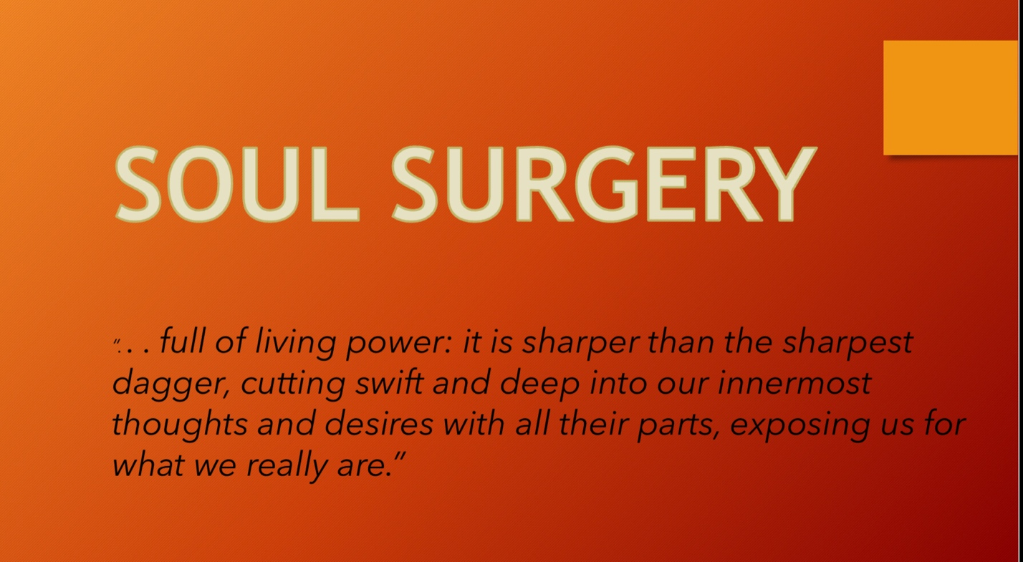

**Soul Surgery and Healing**

*In steps 4 – 11 is where the real work of RAF begins. It requires a careful and deliberate exploratory surgery of the soul.*

Racism acts on the soul as a carcinogen on the body. Once it takes hold, if left untreated it becomes cancerous to the soul and gains a stronghold on the mind and even the body.

We live in a racist environment. No one escapes its carcinogenic effects. Although many have fought to subdue this racist environment, lasting change continues to elude us. That said, as individuals, each of us has the power to address the effects of racism within ourselves.

* I did not cause it.
* I will not continue to host it.
* I will not be complicit in it.

The first step is to acknowledge that we indeed have been impacted by racism and as such are racist.

To become truly aware of the ways we have been impacted by racism, a real way is like performing surgery on your soul. A moral inventory, step four, is the process of going within, cutting through the ego and getting to the very depths of your soul. This can be a very daunting and fearful process; and if attempted alone can cause undo anxiety and unrest.

# Soul surgery, step four, is performed as an exploratory surgery. As the Psalmist said, “Search me, O God, and know my heart; try me and know my thoughts and see if *there be any* wicked way in me, and lead me in the way eternal.”( Psalm 139:23-24

Jubilee Bible 2000).

There are various ways to perform this surgery. The Founder of the Oxford Group, Frank Buchman believed that the personal problems of fear and selfishness were the root of all societal problems. To address these problems Buchman suggested using the four absolutes of Jesus, as shown in Robert Speer’s Principles of Jesus (1904), as a mirror. Most of the Alcoholics Anonymous Program we know today was based off teachings of The Oxford Group.

**The Four Absolutes**

The four absolutes, though recognized as impossible to attain, are guidelines to help determine whether a course of action reflected the God of your understanding.

1. Honesty- Is it True or Is It False?

Honesty refers to a facet of moral character and connotes positive and virtuous attributes such as integrity, truthfulness, straightforwardness (both verbally and through our actions), along with the absence of lying, cheating, theft, etc.

When in active addiction this may seem like a foreign concept to us; now in recovery we are told that complete honesty is a must! It’s a big change for most of us to take in all at once.  The real virtue of honesty lies in the persistent dedication of striving for it.

We need to leave our rationalizations by the wayside and stop the self-deceiving that is in our nature and ask our self “is it true or false?”

The unrelenting pursuit of truth will set us free.

1. Purity – Is it Right or Is It Wrong?

Purity is defined as the condition or quality of being [pure](http://www.dictionary.com/browse/pure); freedom from anything that debases, contaminates, or pollutes.  Purity is a flawless quality.  The question asked “is it right or wrong?” is not a hard concept for us to grasp. Often, even in the grips of our addiction, we were aware of the difference between right and wrong. We are often faced with decisions that are tough for us. We often times know what the right thing is to do but we struggle to do it. By practicing this absolute we are better able to make choices and decisions based on the right thinking that will help us line up our lives with Gods will.

Purity as in Honesty the virtue lies in striving for it, we will also be in constant pursuit. This is a great way to check your motives and find out if we have hidden agendas.

1. Unselfishness- How will this affect another fellow?

Unselfishness is defined as the quality of not putting yourself first, but being willing to give your time, money, or effort etc. Coming into recovery this is often a shift in paradigm for us. We have spent most of our lives thinking of ourselves first, even if we were unaware that we were doing it.

What we gain in sobriety is directly proportionate to what we give away. Once we have realized this and devote time to helping others, we realize that this is the cornerstone of the recovery program.

When analyzing what we are about to do, say, or decide we must first take a look at how this will affect others around us. We have to find out what controls our actions –self-interest or God-interest? This will help us find out if we are self-directed or God-directed.

1. Love- Is It Ugly or Is It Beautiful?

Love is beauty, it is also an action word. When we are in active addiction, we are in the depths of fear, physical agony, mental torture, and spiritual starvation. We need a complete change. We find that in love, in giving love we receive it. Unless we give love, our progress will be lost.

**Ways to use Four Absolutes**

1. As a way to take inventory of our past to see where and how we fell short, so that we could learn what areas of our life needed to be worked on.
2. During meditation or while being inspired or guided by our Inner Voice, as a way to differentiate between “God” thoughts and human thoughts.
3. As a standard of living God’s Will, moment by moment.

**Why is this important for recovery from racism?**

When working a program of recovery, we know that taking inventory is vital. Here are some of the questions that are asked in the Big Book of Alcoholics Anonymous that are in line with The Four Absolutes

1. Where had we been selfish, dishonest, self-seeking and frightened
2. Continue to watch for selfishness, dishonesty and fear.
3. Where we were resentful, selfish, dishonest and afraid.

The Four Absolutes and the questions associated with them are a helpful way to do the right thing when the answer is not obvious.

Answering these queries every day with absolute integrity, and following the dictates of those answers, one day at a time, will surely lead us well on our journey toward applying the Absolutes.